10. Implementing transactions to ensure data integrity and consistency. (use BEGINTRANSACTION\STARTTRANSACTION, COMMIT,ROLLBACK along with other sql queries).

use dbmt;
show databases;
start transaction;
COMMIT;
ROLLBACK;
create database job2;
show databases;

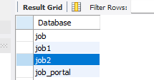

use job2;
CREATE TABLE account4(
account_id INT PRIMARY KEY,
name VARCHAR(50),
balance DECIMAL(10,2)
);
INSERT INTO account4 VALUES
(1,'Karuna',1000.00),
(2,'Roma',500.00);
SELECT*FROM account4;

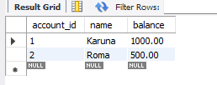

START TRANSACTION;
UPDATE account4
SET balance=balance-200
WHERE account_id=1;
SELECT*FROM account4;

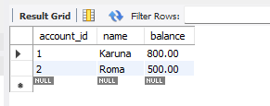
UPDATE account4
SET balance=balance+200
WHERE account_id=2;
SELECT*FROM account4;
COMMIT;

